


Higher Nationals in Computing

Unit 30: Application Development
ASSIGNMENT 1

Learner’s name: Huynh Cam Hung
ID: GCS18026
Class: GCS0701A
Subject code: 1670
Assessor name: LE NGOC THANH

Assignment due: 04 May 2020 Assignment submitted: 04 May 2020
ASSIGNMENT 1 FRONT SHEET
Qualification | BTEC HND Diploma in Computing and Systems Development
Unit number and title | Unit 30: Application Development
Assignment due | 04 May 2020 | Assignment submitted | 04 May 2020
Learner’s name | Huynh Cam Hung | Assessor name | Le Ngoc Thanh

Learner declaration:
I certify that the work submitted for this assignment is my own and research sources are fully acknowledged.
Learner signature |  | Date

Grading grid
P1 | P2 | P3 | M1 | M2 | D1

Assignment title | Assignment 1: Requirement Analysis and Application Design
In this assignment, you will have opportunities to provide evidence against the following criteria.
Indicate the page numbers where the evidence can be found.

Assessment criteria | Expected evidence | Task | Assessor’s Feedback
LO1. Produce a Software Design Document by analysing a business-related problem and deduce an appropriate solution including a set of initial requirements
P1 Explore a business-related problem and produce a well-defined Problem Definition Statement supported by a set of user and system requirements. | 1. Use case diagram to capture problem requirements  2. Screen-flow diagram and wireframes (prototype screen) | 1
P2 Determine any areas of risk related to the successful completion of your application. | 3. Questions to identity any problem from the requirements, use cases, screen-flow diagram or UI  4. Answer to above questions according to personal research | 2
LO2. Use design and development methodologies with tools and techniques associated with the creation of a business application
P3 Research the use of software development tools and techniques and identify any that have been selected for the development of this application. | 5. ERD describing application database  6. UML Class diagram for the core business processing | 3

Assessment criteria | Expected Evidence | Feedback  (note on Merit/Distinction if applicable)
Merit descriptor No. (M1)
Merit descriptor No. (M2)
Distinction descriptor No. (D1)

Summative feedbacks:

Assessor’s Signature |  | Date:

Unit Number and Title | 30: Application Development
Academic Year | 2020
Unit Tutor | Le Ngoc Thanh
Assignment Title | Assignment 1: Requirement Analysis and Application Design
Issue Date
Submission Date | 04 May 2020
IV Name & Date

Learning Outcomes and Assessment Criteria
Pass | Merit | Distinction
LO1 Produce a Software Design Document by analysing a business-related problem and deduce an appropriate solution including a set of initial requirements |  | LO1 & 2  D1 Justify the tools and techniques chosen to realise a custom built website. Justify your preferred selection of tools and techniques in deducing an appropriate solution to a business related problem.
P1 Explore a business-related problem and produce a well-defined Problem Definition Statement supported by a set of user and system requirements.  P2 Determine any areas of risk related to the successful completion of your application. | M1 Analyse a business-related problem using appropriate methods and produce a well-structured Software Design Document that defines a proposed solution and includes relevant details on requirements, system analysis, system design, coding, testing and implementation.
LO2 Use design and development methodologies with tools and techniques associated with the creation of a business application
P3 Research the use of software development tools and techniques and identify any that have been selected for the development of this application. | M2 Compare the differences between the various software development tools and techniques researched and justify your preferred selection as well as your preferred software development methodology.

Assignment Brief and Guidance
As the technology is being developed rapidly nowadays, FPT Co. desires to build the continuing study environment throughout the corporation. It is necessary to develop a web-based system, which manages the activity of “Training” for internal training program of the company. This system can be used to manage trainee accounts, manage trainers, manage course categories, manage courses, manage topics, assign topic to course, assign trainer to topic, assign trainee to course.
This is a system used by HR department. We have three roles in this system, an administrator, training staff and a trainer. The brief description of those roles is as follow.
- An administrator’s role
  - Can login to the system through the first page of the application
  - Can create/edit/delete new user account for trainer/training staff and assign/change(if existing user) username and a password
- A training staff’s role
  - A registered training staff, who is assigned a user name and a password by the administrator logs in can create trainee accounts by entering details like trainee name, trainee accounts, age, date of birth, education, main programming language, TOEIC score, experience details, department, location, etc.
  - After entering successfully all details for trainees, his/her details are then stored in the database. The training staff is given a list of trainees for him to view and search. From the list of trainees, he can also search by trainee account, programming language, TOEIC score…
  - Can update, delete trainee accounts
  - Can manage course categories such as searching, adding, updating and deleting course categories. Course category includes the information such as course category name and descriptions.
  - Can manage courses such as searching, adding, updating and deleting courses. Course includes course name and description.
  - Can add topics such as topic name and topic descriptions into a course, add courses into a category.
  - Can manage trainer profile such as adding, updating and deleting the information: Trainer name, External or Internal Type, working place, telephone, and email address.
  - Can assign trainer to a topic.
  - Can assign trainee to a course.
- A trainer’s role
  - In the same system, the trainer who have been registered by the administrator can login and can update his profile such as Trainer name, External or Internal Type, education, working place, telephone, and email address.
- Can view courses which have a topic he is assigned to.

Your manager suggests that this would be a great opportunity for you to demonstrate your capabilities by designing and developing the application. After considering, you decide to do the project. The project consists of 4 steps which is divided into two phases. In this first phase, you have to carry on requirement analysis and produce solution design for the problem.
Assignment Guidance
Task | Assessment Criteria | Requirement
1 | P1 Explore a business-related problem and produce a well-defined Problem Definition Statement supported by a set of user and system requirements. | - Use case diagram to capture problem requirements  - Screen-flow diagram and wireframes (prototype screen)
2 | P2 Determine any areas of risk related to the successful completion of your application. | - Questions to identity any problem from the requirements, use cases, screen-flow diagram or UI  - Answer to above questions according to personal research
3 | P3 Research the use of software development tools and techniques and identify any that have been selected for the development of this application. | - ERD describing application database  - UML Class diagram for the core business processing
4 | M1 Analyse a business-related problem using appropriate methods and produce a well-structured Software Design Document that defines a proposed solution and includes relevant details on requirements, system analysis, system design, coding, testing and implementation. | - Detail use case description for important functions
5 | M2 Compare the differences between the various software development tools and techniques researched and justify your preferred selection as well as your preferred software development methodology. | - A presentation to introduce different software development methods (at least 3), for example: Waterfall, Prototyping, Spiral, Agile…
6 | D1 Justify the tools and techniques chosen to realise a custom built website. Justify your preferred selection of tools and techniques in deducing an appropriate solution to a business related problem. | - Critical comparison among development methods in the presentation and reasons for your selection of tools and techniques.

Submission Format
The submission is in the form of 1 word document containing required evidences and 1 presentation if necessary (M2, D1).
You are required to make use of headings, paragraphs, subsections and illustrations as appropriate, and all work must be supported with research and referenced using the Harvard referencing system.

Table of contents
1. System requirements 1
2. System Architecture 2
2.1. Design model 2
2.2. UML diagrams 4
2.2.1. Use case diagram 4
2.2.2. Class Diagram 16
2.2.3. ERD diagram 19
2.2.4. Screen flow diagram 21
3. Wire frame of system 22
3.1. Login page 22
3.2. Login as Administrator 24
3.3. Login as Training staff 29
3.4. Login as Trainer 62
3.5. Login as Trainee 67
4. Table of questions to identity the risk 72
References 74

- System requirements
According to the requirements, we have to develop an web application which includes four roles to participate in it: Admin, Training Staff, Trainer, and Trainee. Four of them have an account to login and participate in the system.
- Admin
Attributes: Not include
Behaviors:
- Have the right to manage account such as Add, Delete, Search the account.
- Can update the account username and password.
- Training staff
Attributes: Not include
Behaviors:
- Have the right to manage Course Category, Course, and Topic such as Add, Delete, Search, and Update.
- Also can manage the trainee account and profile, and assign the trainer to topic and course, and trainee to course.
- Trainer
Attributes: Name, External or Internal Type, education, working place, telephone, and email address.
Behaviors:
- Can see the topics and courses he or she is assigned to.
- Can modify their profile information.
- Trainee
Attributes: Name, Date of birth, education, main programming language, TOEIC score, experience details, department, location.
Behaviors: Not included
- System Architecture
  - Design model
The design model applied to design the application is MVC (Model - View - Controller). MVC is the shorten word of three components of the model: Model, View, Controller. This is a design model mostly used in software engineering. MVC model divided the source code into 3 parts, corresponding to each word. Each word corresponds to a separate activity in a model.
To better understand, we will go along to discuss each component.
- Component of MVC:
- Model
Model is a component to store all data of the application. This unit is a bridge between the two components below are View and Controller. The model takes the form of a database or sometimes just a normal XML file. Model clearly shows the manipulations with the database such as allowing viewing, accessing, processing data, and so on.
- View
This component contain code of the application interface. Where users can obtain MVC data information through query operations such as searching or using through websites.
Typically, web applications use View as part of the system where HTML elements are created. Besides, View also has a function to record the user's activity to interact with the Controller. However, the View does not have a direct relationship with the Controller, nor is it able to retrieve data from the Controller, but only displays the request for the Controller to pass.
For instance, the "delete" button created by the View when the user clicks the button will have an action in the Controller.
  - Controller
The component is responsible for handling user requests coming through the View. When the requests come, the Controller will manipulate the request and then interact with the Model to get the data users want. From there, Controller can gives data that is right for the user.
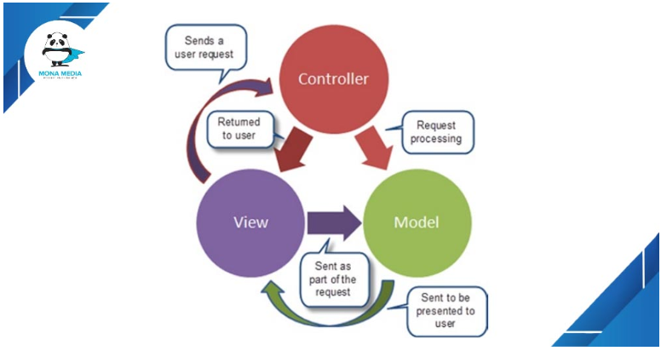
Figure 1 : Components of MVC model
In general, the MVC model is not complicate. As you can imagine, when a request is sent from the client to the server, the Controller will perform its task of receiving and processing the request. In case of need, it is possible to contact the Model, who works with the database, to assist. When the request is processed, the result will be returned to the View. At View will create HTML code into the interface and render displayed on the browser. MVC is a model that is used a lot in web application programming. A well-developed MVC system will allow front-end, back-end development on the system without interference, sharing, editing files while one or both parties are still working. Therefore, I use the model to design the application.
  - UML diagrams
    - Use case diagram
- Administrators
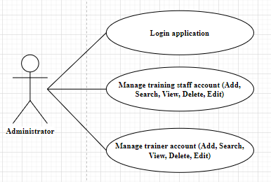
Figure 2 : Use case diagram of administrators
Name | Manage trainer/staff account
Description | Admin can add, search, view, edit and delete the trainer/staff accounts.
Actor | Administrator
Goal | - Add new trainer/staff accounts.  - Search trainer/staff account and view the information.  - Update username and password of existing trainer/staff account.  - Delete existing trainer account/staff.
Trigger | Admin need to add, search, update, delete trainer/staff accounts.
Normal flow | Admin has to log in into the application:  - Add account:  - Admin visited add new account page.  - Admin insert username and password for new account  - Admin confirm to save the account  - Search account:  - Admin visited the home page.  - Admin insert the keyword into the search bar.  - Admin confirm to search the account via keyword.  -Update account:  - Admin search for the account need to be updated.  - Admin enter update page with the button.  - Admin modify the account information in fields.  - Admin confirm to update the account information  -Delete account:  - Admin search for the account need to be deleted.  - Admin command to delete the account with the button.  - Admin confirm to delete the account.

- Training Staff
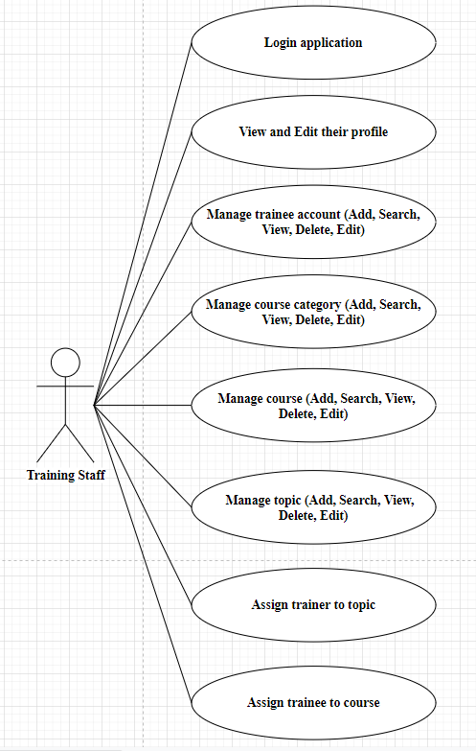
Figure 3 : Use case diagram of training staffs

Name | View and edit profile
Description | Staff can view and edit their own profile.
Actor | Training Staff
Goal | - Visit the profile page and see the information.  - Update the profile information
Trigger | Staff need to change their profile information.
Normal flow | Staff has to log in into the application:  - Visited the profile page.  - Change the information in the field.  - Confirm to update the profile information.

Name | Manage trainee account /category /course /topic.
Description | Staff can add, search, view, edit and delete thetrainee account /category /course /topic.
Actor | Training Staff
Goal | - Add new trainee account /category /course /topic.  - Search trainee account /category /course /topic and view the information.  - Update existing trainee account /category /course /topic information.  - Delete existing trainee account /category /course /topic.
Trigger | Staff need to add, search, update, delete trainee account /category /course /topic.
Normal flow | Staff has to log in into the application:  - Add new:  - Staff visited add new page.  - Staff insert information for new entity.  - Staff confirm to save the new entity  - Search:  - Staff visited the page show list of records.  - Staff insert the keyword into the search bar.  - Staff confirm to search the records via keyword.  -Update account:  - Staff search for the record need to be updated.  - Staff enter update page with the button.  - Staff modify the information in fields.  - Staff confirm to update the information  -Delete account:  - Staff search for the record need to be deleted.  - Staff command to delete the record with the button.  - Staff confirm to delete the record.

Name | Assign trainer to topic
Description | Staff can assign the trainers to the topics which trainer will teach to trainees.
Actor | Training Staff
Goal | Assign the existing trainers into an existing topic.
Trigger | Staff need to assign trainers into the topics.
Normal flow | Staff has to log in into the application:  - Search for an existing topic.  - Enter edit page of the topic.  - Insert trainer id into field  - Assign the trainer having the id into the topic with the button

Name | Assign trainee to course
Description | Staff can assign the trainees to the courses which trainee need to participate.
Actor | Training Staff
Goal | Assign the existing trainees into an existing course.
Trigger | Staff need to assign trainees into the courses.
Normal flow | Staff has to log in into the application:  - Search for an existing course.  - Enter edit page of the course.  - Insert trainee id into field.  Assign the trainee having the id into the course with the button.

- Trainer

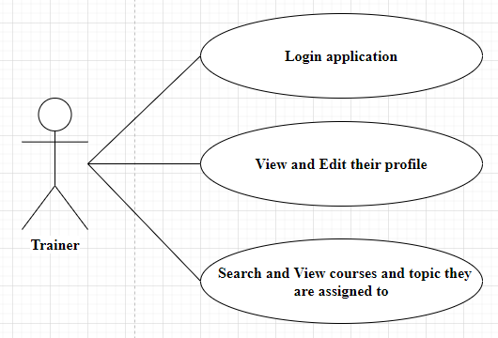
Figure 4 : Use case diagram of trainers
Name | View and edit profile
Description | Trainer can view and edit their own profile.
Actor | Trainer
Goal | - Visit the profile page and see the information.  - Update the profile information
Trigger | Trainer need to change their profile information.
Normal flow | Trainer has to log in into the application:  - Visit the profile page.  - Change the information in the field.  - Confirm to update the profile information.

Name | Search and view the assigned topics and courses.
Description | Trainer can view the topics and courses they are assigned to.
Actor | Trainer
Goal | Visit the page show list of teaching topics and courses.
Trigger | Trainer need to see the list of topics and courses they are assigned to.
Normal flow | - Trainer log in into the application.  - Visit the home page.

- Trainee
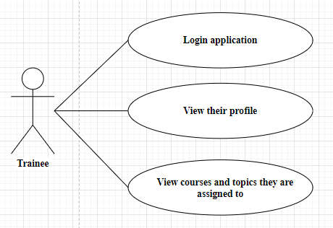
Figure 5 : Use case diagram of trainees
Name | View profile
Description | Trainee can view and edit their own profile.
Actor | Trainee
Goal | - Visit the profile page and see the information.
Trigger | Trainee want to see their profile information.
Normal flow | Trainee has to log in into the application:  - Visit the profile page.  - See the information of their own profile.

Name | Search and view the assigned courses.
Description | Trainee can view the courses they are assigned to.
Actor | Trainee
Goal | Visit the page show list of studying courses.
Trigger | Trainer need to see the list of courses they are assigned to.
Normal flow | - Trainee log in into the application.  - Visit the home page.

    - Class Diagram
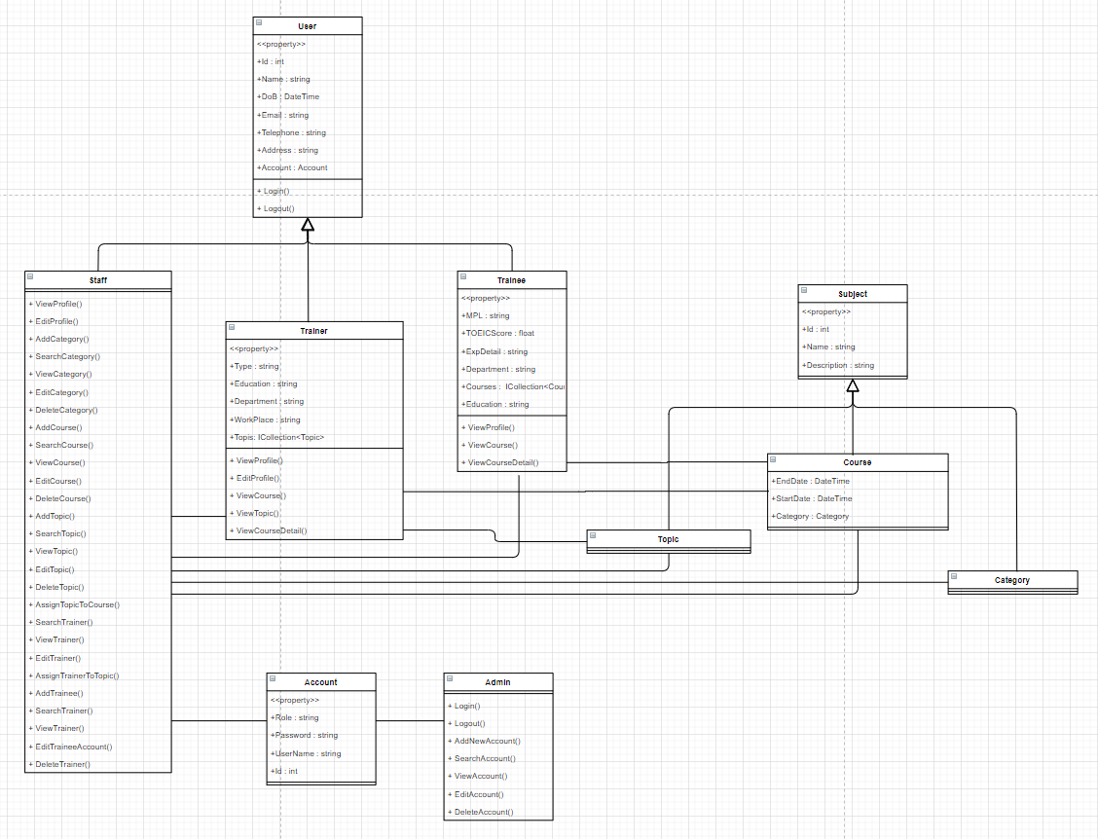
Figure 6 : Class diagram of the application

To provide the specific detail of the class diagram, I use the table below illustrates the relationship between classes.
Order | Classes | Actions | Classes | Relationships
1 | Admin | Manage | Account | Association
2 | Staff | Inherit | User | Generalization
3 | Trainer | Inherit | User | Generalization
4 | Trainee | Inherit | User | Generalization
5 | Staff | Has | Account | Association
6 | Staff | Manage | Trainee | Association
7 | Staff | Assign | Trainer | Association
8 | Staff | Manage | Category | Association
9 | Staff | Manage | Courses | Association
10 | Staff | Manage | Topic | Association
11 | Trainer | Has | Account | Association
12 | Trainer | Has | Topic | Association
13 | Trainer | Teach | Course | Association
14 | Trainee | Has | Account | Association
15 | Trainee | Learn | Course | Association
16 | Category | Inherit | Subject | Generalization
17 | Course | Inherit | Subject | Generalization
18 | Topic | Inherit | Subject | Generalization
19 | Course | Belong to | Category | Composition
20 | Topic | Belong to | Course | Composition

    - ERD diagram
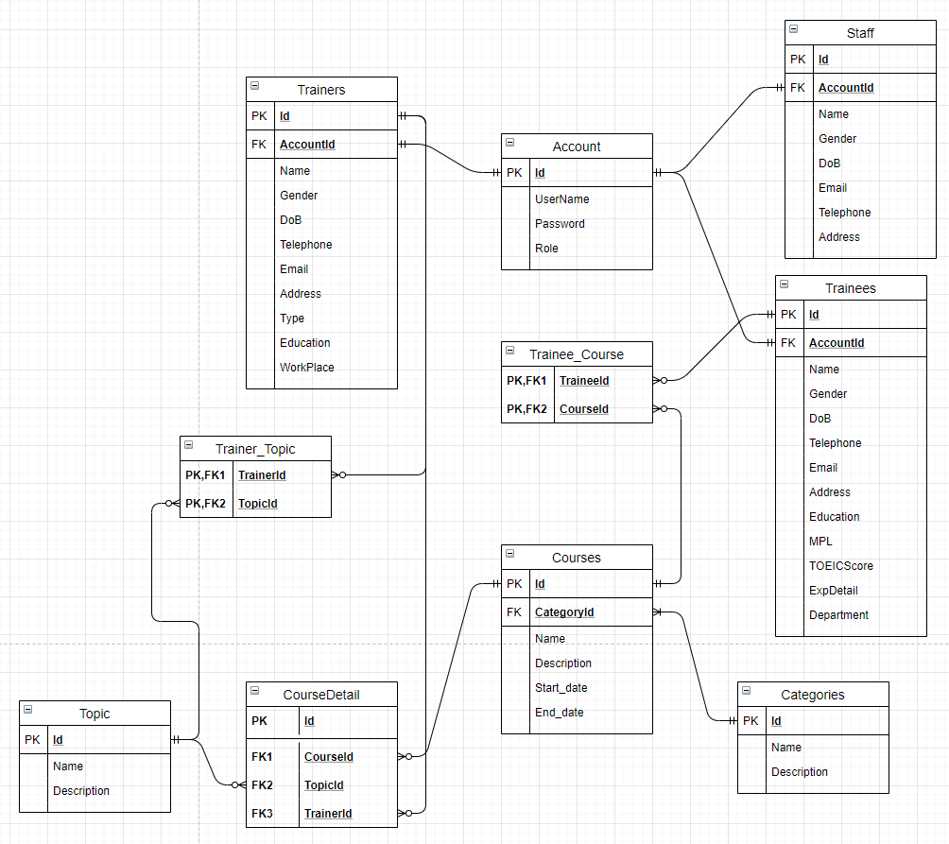
Figure 7 : The ERD design for the application

The following table describe the relationships between entity.
Entities | Relationships | Entities
Account | One to One | Staff
Account | One to One | Trainer
Account | One to One | Trainee
Course | One to Many | CourseDetail
Topic | One to Many | CourseDetail
Trainer | One to Many | CourseDetail
Trainer | Many to Many | Topic
Category | One to Many | Course
Trainee | Many to Many | Course

    - Screen flow diagram
- Administrator
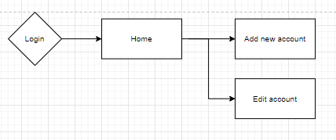
Figure 8 : Screen flow diagram when login as admin
- Training Staff
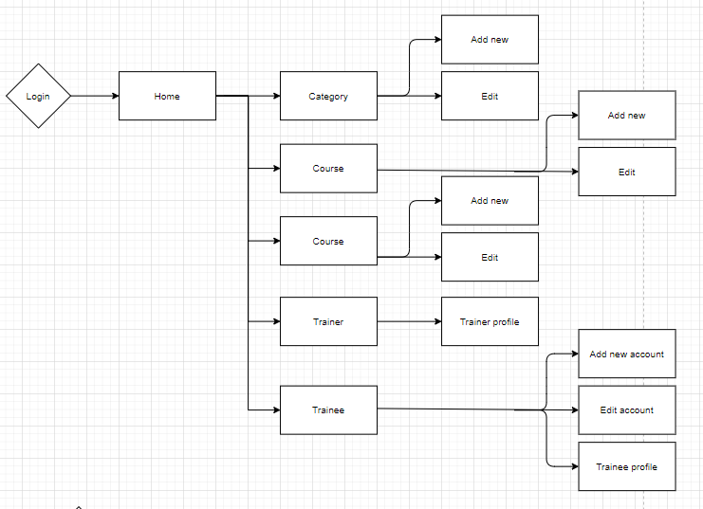
Figure 9 : Screen flow diagram when login as training staff
- Trainer and Trainee
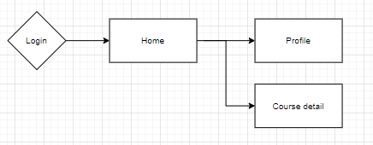
Figure 10 : Screen flow diagram when login as trainer and trainee

- Wire frame of system
Wireframe is an important tool in product design and development. When creating a product, a wire frame is a design that helps developers, product managers, and designers can talk to each other. And whenever there is a change in the interface, everyone is easy and quick to understand and implement. Wireframe can be done quickly on paper or in computer form.
  - Login page
When user visit the url of application, the system will require user to enter valid username and password. If the username or password does not exist, user will can not login the system, and the page will inform user to re-enter username and password.
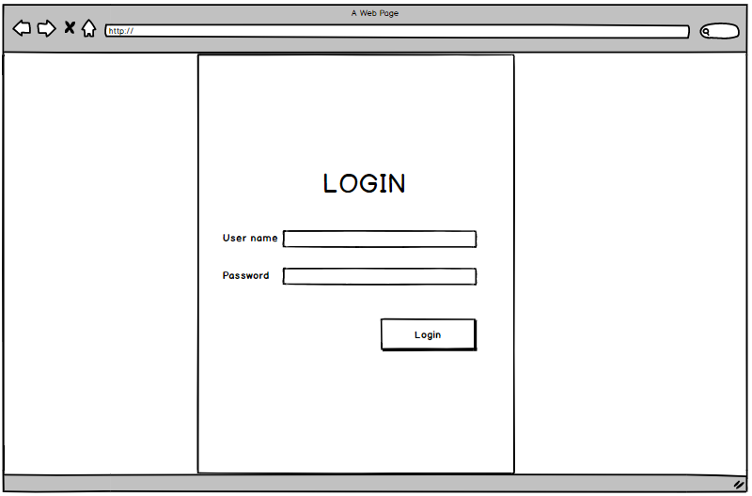
Figure 11 : Wire frame of login page
No | Item | Description | Constraints
1 | Username text box | Input field for username | Min 3 characters and Max 20 characters.
2 | Password text box | Input field for password | Min 3 characters and Max 20 characters.
3 | Login button | The button will submit the username and password to server

  - Login as Administrator
As the system has four different roles, users with different role will see different interfaces of the application. The below interfaces are designed for administrators.
- Home page
In the home page, administrators will see list of account exist in the system. In here, they can also search the specific accounts via the search box.
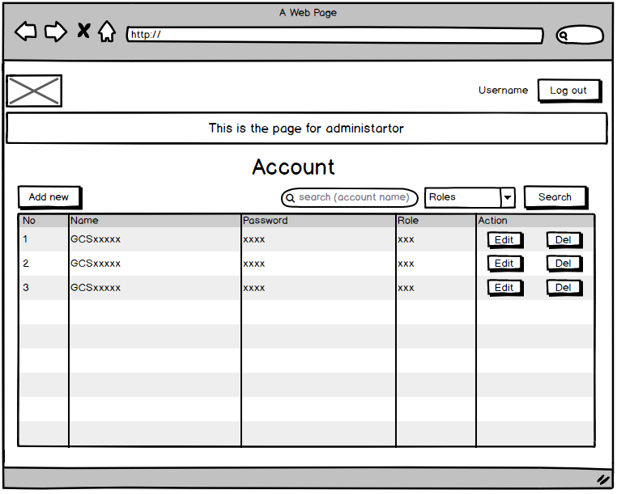
Figure 12 : Wire frame of home page for admin

No | Item | Description | Constraints
1 | Logo picture | The logo of the application and it is assigned the home page link.
2 | Username label | Show the username of the login account
3 | Log out button | User will log out the application if click on it.
4 | Add new button | User will go to add new page if click on it
5 | Search box | User can search account via user name | Min 1 characters and Max 20 characters.
6 | Search combo box | User can search account via role | Only includes All, Admin, Staff, Trainer, Trainee.
7 | Search button | User can search account if click on it
8 | Account table | User can see list of account
9 | Edit button | User will go to edit page if click on it
10 | Del button | User will delete account if click on it

- Add new account
The below page let the admin create the new account. To visit the page, admin have to click the “Add new” button in the home page.
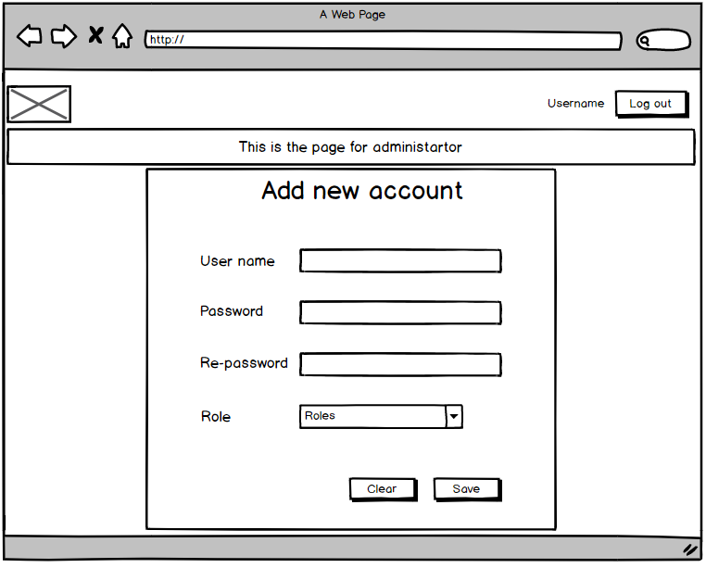
Figure 13 : Wire frame for admin add new account
No | Item | Description | Constraints
1 | Logo picture | The logo of the application and it is assigned the home page link.
2 | Username label | Show the username of the login account
3 | Log out button | User will log out the application if click on it.
4 | Username text box | Input field for username | Min 3 characters and Max 20 characters.
5 | Password text box | Input field for password | Min 3 characters and Max 20 characters.
6 | Re-password text box | Input field for re-password which will check the input password again | - Min 3 characters and Max 20 characters.  - Value similar with password text box
7 | Role combo box | User can select role for the account | Only includes Admin, Staff, Trainer, Trainee.
8 | Clear button | The button will clear the value of all input field
9 | Save button | The button will save the new account into the system.

- Edit account
The below page let the admin edit the existing account. To edit the specific account, admin have to click the “Edit” button which in the same row with the account in the table.
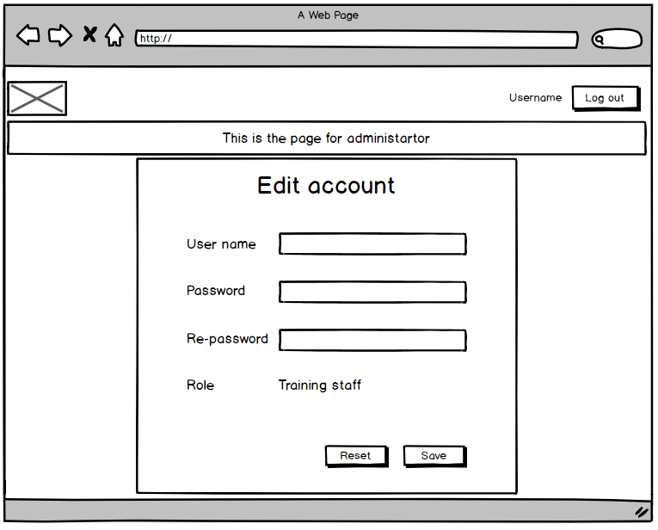
Figure 14 : Wire frame for admin edit the account
No | Item | Description | Constraints
1 | Logo picture | The logo of the application and it is assigned the home page link.
2 | Username label | Show the username of the login account
3 | Log out button | User will log out the application if click on it.
4 | Username text box | Input field for username | Min 3 characters and Max 20 characters.
5 | Password text box | Input field for password | Min 3 characters and Max 20 characters.
6 | Re-password text box | Input field for re-password which will check the input password again | - Min 3 characters and Max 20 characters.  - Value similar with password text box
7 | Role label | Show the role of the account
8 | Reset button | The button will reset the origin value of all input field
9 | Save button | The button will update the account information.

  - Login as Training staff
The following is the designed wire frame for training staffs.
- Home page
The Home page is the profile page of the training staff. In here, staffs can edit their profile by click the “Save” button after change the information. Furthermore, the home page can be visited easily by click the button “Username” in the above right corner.
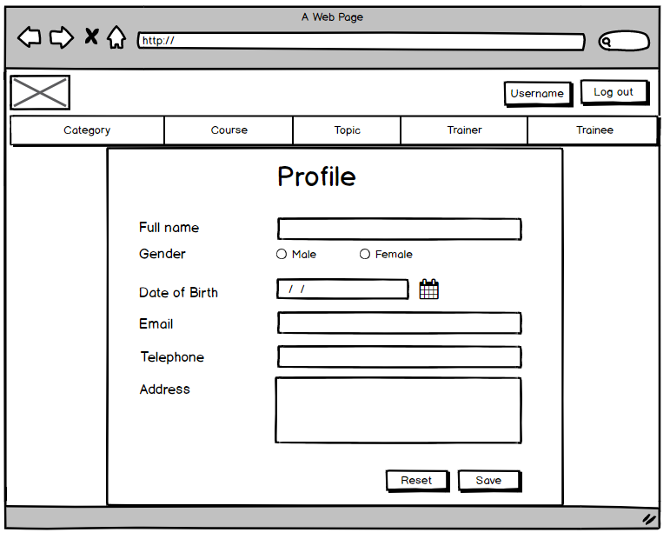
Figure 15 : Wire frame of home page for staff
No | Item | Description | Constraints
1 | Logo picture | The logo of the application and it is assigned the home page link.
2 | Username label | Show the username of the login account and assigned profile page link to it
3 | Log out button | User will log out the application if click on it.
4 | Full name text box | Input field for staff name | Min 3 characters and Max 20 characters.
5 | Male and female radio button | User can select gender
6 | Date of birth date input field | Input field for date of birth
7 | Email text box | Input field for email | Email syntax
8 | Telephone text box | Input field for phone number | Only number characters
9 | Address text area | Input field for address | Min 3 characters
10 | Reset button | The button will reset the value of all input field
11 | Save button | The button will update the staff profile information.

- Category main page
The below page show the list of exist categories included in the system. To visited the page, staffs have to click the “Category” tab on the navigation bar.
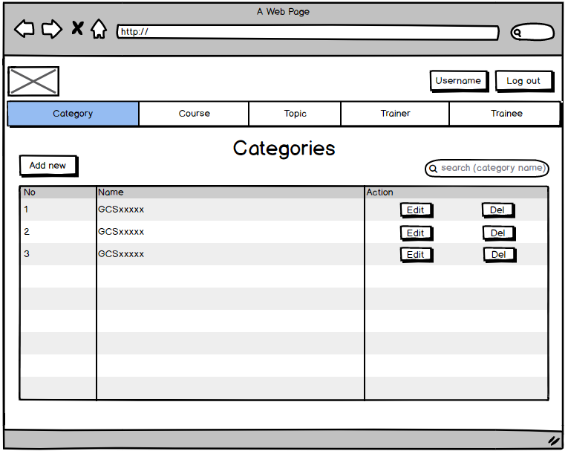
Figure 16 : Wire frame of Category main page
No | Item | Description | Constraints
1 | Logo picture | The logo of the application and it is assigned the home page link.
2 | Username label | Show the username of the login account and assigned profile page link to it
3 | Log out button | User will log out the application if click on it.
4 | Add new button | User will go to add new page if click on it
5 | Search box | User can search category via name | Min 1 characters and Max 20 characters.
6 | Categories table | User can see list of category
7 | Edit button | User will go to edit page if click on it
8 | Del button | User will delete category if click on it

- Add new category
The below page let the staff add the new category into the system. To visit the page, admin have to click the “Add new” button in the Category main page.
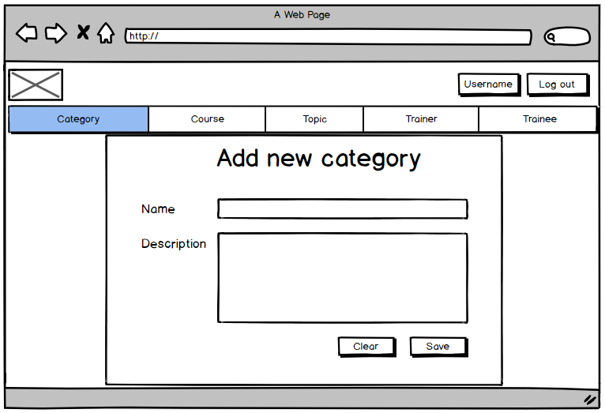
Figure 17 : Wire frame for add new category
No | Item | Description | Constraints
1 | Logo picture | The logo of the application and it is assigned the home page link.
2 | Username label | Show the username of the login account and assigned profile page link to it
3 | Log out button | User will log out the application if click on it.
4 | Name text box | Input field for category name | Min 3 characters and Max 20 characters.
5 | Description text area | Input field for description
6 | Clear button | The button will clear the value of all input field
7 | Save button | The button will save the new category into the system.

- Edit category
The below page let the staffs edit the existing category. To edit the specific category, admin have to click the “Edit” button which in the same row with the category in the table.
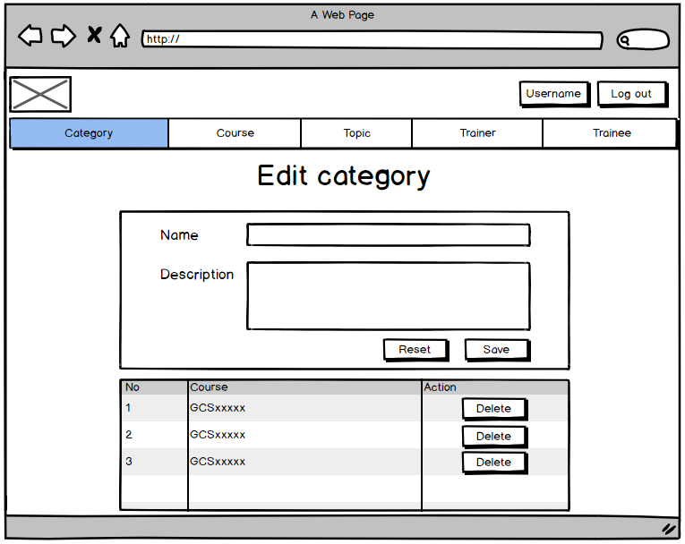
Figure 18 : Wire frame for edit category
No | Item | Description | Constraints
1 | Logo picture | The logo of the application and it is assigned the home page link.
2 | Username label | Show the username of the login account and assigned profile page link to it
3 | Log out button | User will log out the application if click on it.
4 | Name text box | Input field for category name | Min 3 characters and Max 20 characters.
5 | Description text area | Input field for description
6 | Reset button | The button will reset the origin value of all input field
7 | Save button | The button will update the category information.
8 | Course table | The table show list of course which is belonged to the category
9 | Delete button | Remove the course from this category but not delete it

- Course main page
The below page show the list of exist courses included in the system. To visited the page, staffs have to click the “Course” tab on the navigation bar.
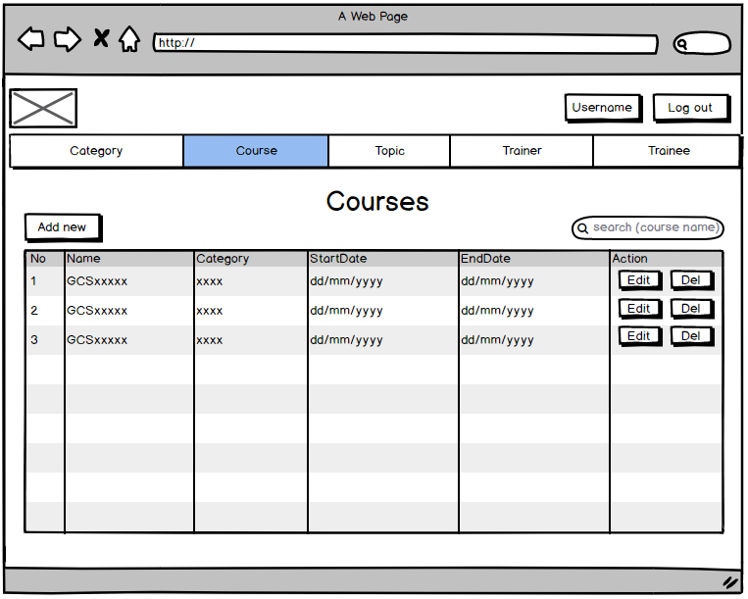
Figure 19 : Wire frame for show list of course
No | Item | Description | Constraints
1 | Logo picture | The logo of the application and it is assigned the home page link.
2 | Username label | Show the username of the login account and assigned profile page link to it
3 | Log out button | User will log out the application if click on it.
4 | Add new button | User will go to add new page if click on it
5 | Search box | User can search courses via name | Min 1 characters and Max 20 characters.
6 | Course table | User can see list of course
7 | Edit button | User will go to edit page if click on it
8 | Del button | User will delete course if click on it

- Add new course
The below page let the staff add the new course into the system. To visit the page, admin have to click the “Add new” button in the Course main page.
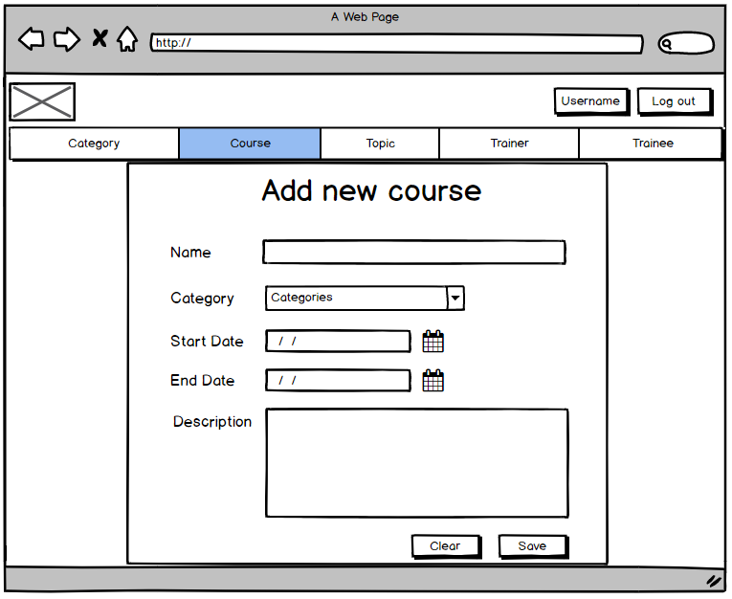
Figure 20 : Wire frame for add new course
No | Item | Description | Constraints
1 | Logo picture | The logo of the application and it is assigned the home page link.
2 | Username label | Show the username of the login account and assigned profile page to it.
3 | Log out button | User will log out the application if click on it.
4 | Name text box | Input field for course name | Min 3 characters and Max 20 characters.
5 | Category combo box | User can select category for course | Only includes category existing in the system.
6 | Start date date input field | Input field for start date of the course
7 | End date date input field | Input field for end date of the course
8 | Description text area | Input field for description
9 | Clear button | The button will clear the value of all input field
10 | Save button | The button will save the new course into the system.

- Edit course
The below page let the staffs edit the existing course. To edit the specific course, admin have to click the “Edit” button which in the same row with the course in the table.
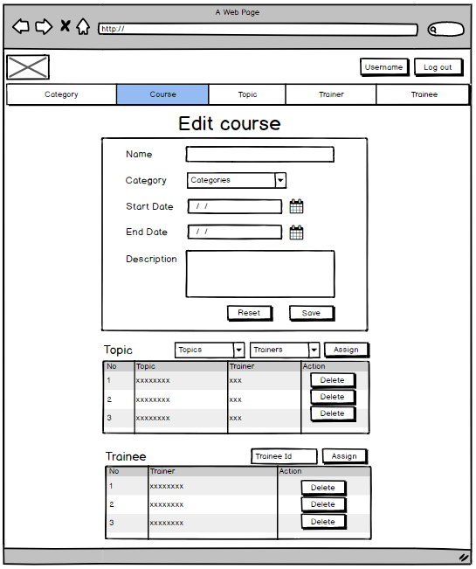
Figure 21 : Wire frame for edit course
No | Item | Description | Constraints
1 | Logo picture | The logo of the application and it is assigned the home page link.
2 | Username label | Show the username of the login account and assigned profile page to it.
3 | Log out button | User will log out the application if click on it.
4 | Name text box | Input field for course name | Min 3 characters and Max 20 characters.
5 | Category combo box | User can select category for course | Only includes categories existing in the system.
6 | Start date date input field | Input field for start date of the course
7 | End date date input field | Input field for end date of the course
8 | Description text area | Input field for description
9 | Reset button | The button will reset the value of all input field
10 | Save button | The button will update the course information.
11 | Topic combo box | User can select topic to assign in the course | Only includes topics existing in the system
12 | Trainer combo box | User can select trainer who teach the topic to assign in the course | Only includes trainers who teach the selected topic
13 | Assign button 1 | Assign the topic into the course
14 | Topic table | The table show list of topic which is assigned to the course.
15 | Delete button | Remove the topic from this course but not delete it
16 | Trainee id text box | User can assign trainee into course via trainee id | Integer value
17 | Assign button 2 | Assign the trainee into the course
18 | Trainee table | The table show list of trainees who is assigned to the course.
19 | Delete button | Remove the trainee from this course but not delete him or her

- Topic main page
The below page show the list of exist topics included in the system. To visited the page, staffs have to click the “Topic” tab on the navigation bar.
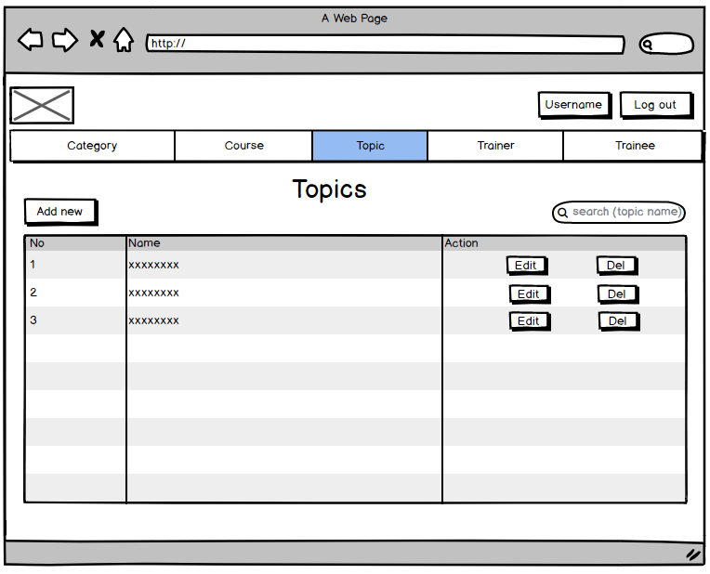
Figure 22 : Wire frame for show list of topics
No | Item | Description | Constraints
1 | Logo picture | The logo of the application and it is assigned the home page link.
2 | Username label | Show the username of the login account and assigned profile page link to it
3 | Log out button | User will log out the application if click on it.
4 | Add new button | User will go to add new page if click on it
5 | Search box | User can search topics via name | Min 1 characters and Max 20 characters.
6 | Topic table | User can see list of topics
7 | Edit button | User will go to edit page if click on it
8 | Del button | User will delete topic if click on it

- Add new topic
The below page let the staff add the new topic into the system. To visit the page, admin have to click the “Add new” button in the Topic main page.
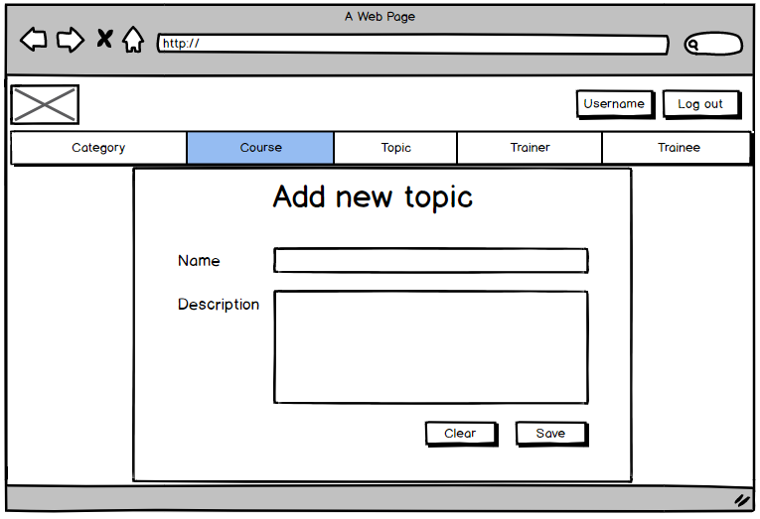
Figure 23 : Wire frame for add new topic
No | Item | Description | Constraints
1 | Logo picture | The logo of the application and it is assigned the home page link.
2 | Username label | Show the username of the login account and assigned profile page link to it
3 | Log out button | User will log out the application if click on it.
4 | Name text box | Input field for topic name | Min 3 characters and Max 20 characters.
5 | Description text area | Input field for description
6 | Clear button | The button will clear the value of all input field
7 | Save button | The button will save the new topic into the system.

- Edit topic
The below page let the staffs edit the existing topic. To edit the specific topic, admin have to click the “Edit” button which in the same row with the topic in the table.
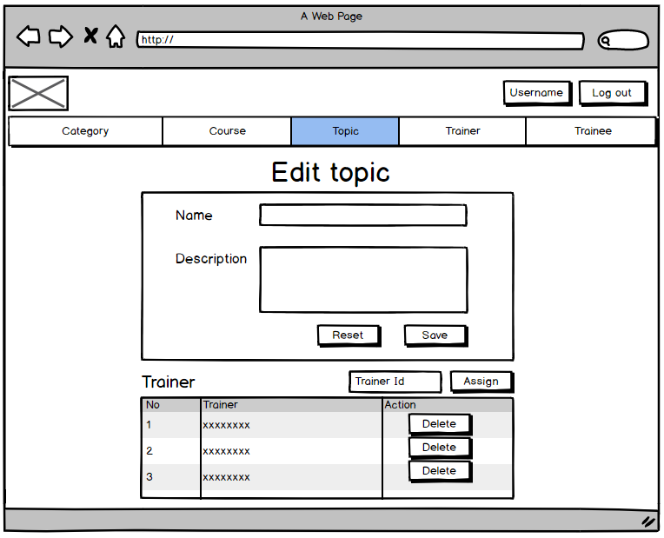
Figure 24 : Wire frame for edit topic
No | Item | Description | Constraints
1 | Logo picture | The logo of the application and it is assigned the home page link.
2 | Username label | Show the username of the login account and assigned profile page link to it
3 | Log out button | User will log out the application if click on it.
4 | Name text box | Input field for topic name | Min 3 characters and Max 20 characters.
5 | Description text area | Input field for description
6 | Reset button | The button will reset the value of all input field
7 | Save button | The button will update the topic information
8 | Trainer id text box | User can assign trainer into topic via trainer id | Integer value
9 | Assign button | Assign the trainer into the topic
10 | Trainer table | The table show list of trainers who is assigned to the topic.
11 | Delete button | Remove the trainer from this topic but not delete him or her

- Trainer main page
The below page show the list of exist Trainers included in the system. To visited the page, staffs have to click the “Trainer” tab on the navigation bar.
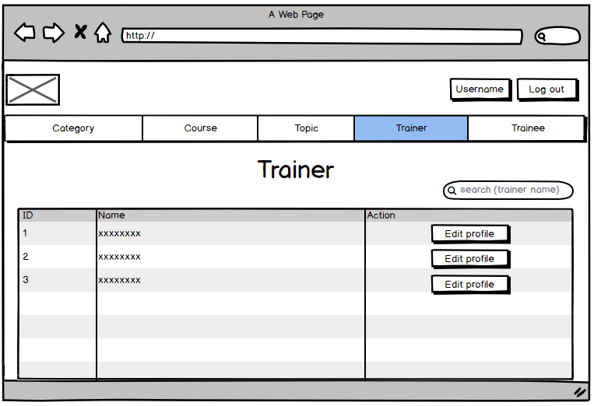
Figure 25 : Wire frame for show list of trainers
No | Item | Description | Constraints
1 | Logo picture | The logo of the application and it is assigned the home page link.
2 | Username label | Show the username of the login account and assigned profile page link to it
3 | Log out button | User will log out the application if click on it.
4 | Search box | User can search trainers via name | Min 1 characters and Max 20 characters.
5 | Trainer table | User can see list of trainers
6 | Edit button | User will go to edit page if click on it
7 | Del button | User will delete trainer if click on it

- Edit trainer profile
The below page let the staffs edit the profile of existing trainer. To edit the specific trainer profile, admin have to click the “Edit profile” button which in the same row with that trainer in the table.
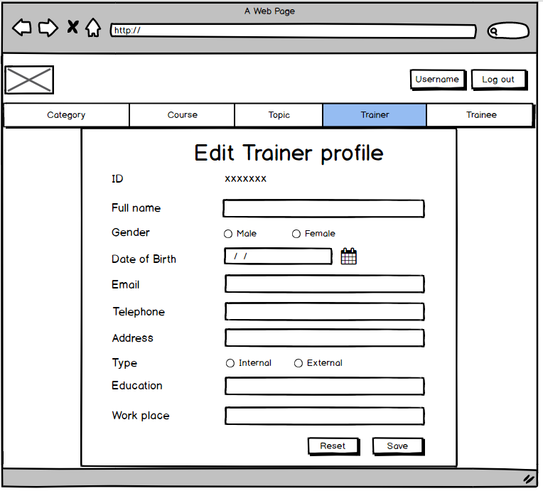
Figure 26 : Wire frame for edit trainer profile
No | Item | Description | Constraints
1 | Logo picture | The logo of the application and it is assigned the home page link.
2 | Username label | Show the username of the login account and assigned profile page link to it
3 | Log out button | User will log out the application if click on it.
4 | Id label | Display the id of trainer
5 | Full name text box | Input field for trainer name | Min 3 characters and Max 20 characters.
6 | Male and female radio button | User can select trainer gender
7 | Date of birth date input field | Input field for date of birth
8 | Email text box | Input field for email | Email syntax
9 | Telephone text box | Input field for phone number | Only number characters
10 | Address text box | Input field for address | Min 3 characters
11 | Internal and external radio button | User can select trainer type
12 | Education text box | Input field for education | Min 3 characters and Max 20 characters.
13 | Work place text box | Input field for work place | Min 3 characters
14 | Reset button | The button will reset the value of all input field
15 | Save button | The button will update the trainer profile information.

- Trainee main page
The below page show the list of exist trainees included in the system. To visited the page, staffs have to click the “Trainee” tab on the navigation bar.
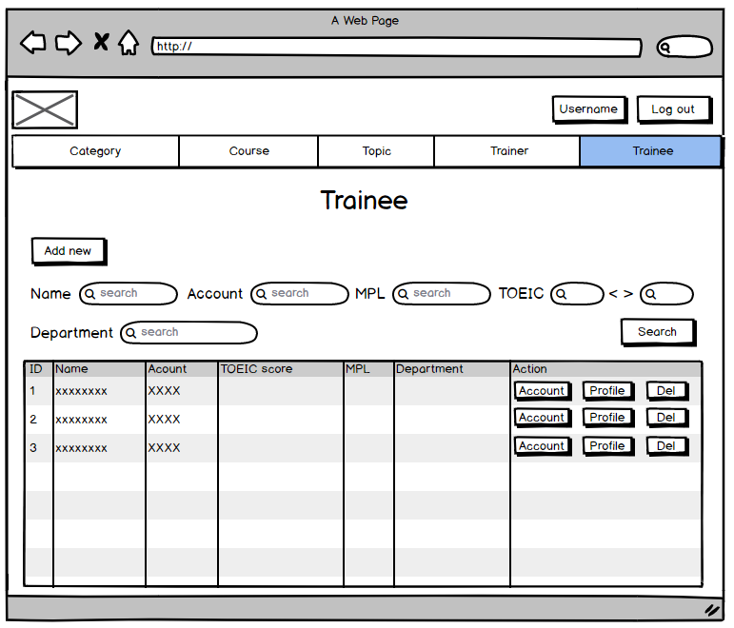
Figure 27 : Wire frame for show list of trainee
No | Item | Description | Constraints
1 | Logo picture | The logo of the application and it is assigned the home page link.
2 | Username label | Show the username of the login account and assigned profile page link to it
3 | Log out button | User will log out the application if click on it.
4 | Add new button | User will go to add new page if click on it
5 | Full name search box | User can search trainee via trainee name | Min 1 characters and Max 20 characters.
6 | Account name search box | User can search trainee via account username | Min 1 characters and Max 20 characters.
7 | MPL search box | User can search trainee via main programming language | Min 1 characters and Max 20 characters.
8 | TOEIC search box 1 | User can search trainee which is higher the specific value | - Integer value  - Min 0 and Max 1000
9 | TOEIC search box 2 | User can search trainee which is lower the specific value | - Integer value  - Min 0 and Max 1000
10 | Department search box | User can search trainee via department | Min 1 characters and Max 20 characters.
11 | Search button | User can search trainee if click on it
12 | Trainee table | User can see list of trainee
13 | Account button | User will go to trainee account edit page if click on it
14 | Profile button | User will go to trainee profile edit page if click on it
15 | Del button | User will delete trainee if click on it

- Add new trainee account
The below page let the staff add the new trainee account into the system. To visit the page, admin have to click the “Add new” button in the Trainee main page.
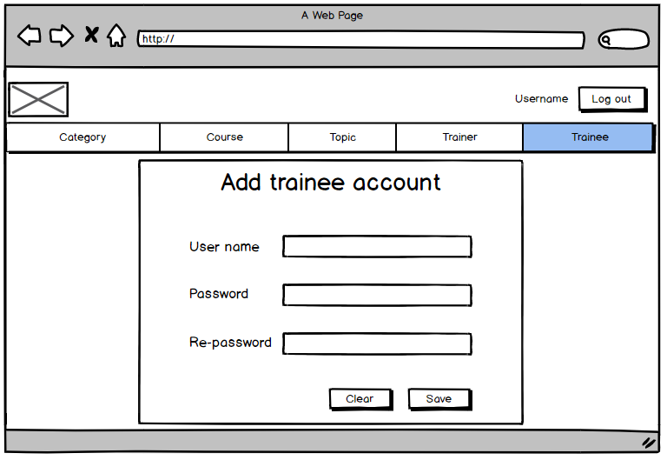
Figure 28 : Wire frame for add new trainee account
No | Item | Description | Constraints
1 | Logo picture | The logo of the application and it is assigned the home page link.
2 | Username label | Show the username of the login account and assigned profile page link to it.
3 | Log out button | User will log out the application if click on it.
4 | Username text box | Input field for username | Min 3 characters and Max 20 characters.
5 | Password text box | Input field for password | Min 3 characters and Max 20 characters.
6 | Re-password text box | Input field for re-password which will check the input password again | - Min 3 characters and Max 20 characters.  - Value similar with password text box
8 | Clear button | The button will clear the value of all input field
9 | Save button | The button will save the new account into the system.

- Edit trainee account
The below page let the staffs edit the username and password of existing trainee account. To edit the specific account, admin have to click the “Account” button which in the same row with that trainee in the table.
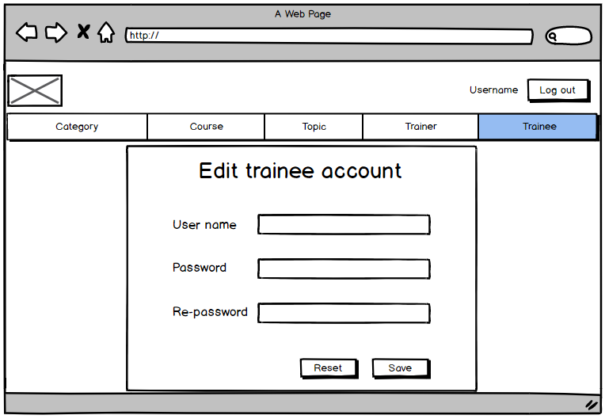
Figure 29 : Wire frame for edit trainee account
No | Item | Description | Constraints
1 | Logo picture | The logo of the application and it is assigned the home page link.
2 | Username label | Show the username of the login account and assigned profile page link to it.
3 | Log out button | User will log out the application if click on it.
4 | Username text box | Input field for username | Min 3 characters and Max 20 characters.
5 | Password text box | Input field for password | Min 3 characters and Max 20 characters.
6 | Re-password text box | Input field for re-password which will check the input password again | - Min 3 characters and Max 20 characters.  - Value similar with password text box
8 | Reset button | The button will reset the value of all input field
9 | Save button | The button will update the account information.

- Edit trainee profile
The below page let the staffs edit the profile of existing trainee. To edit the specific trainee profile, admin have to click the “Profile” button which in the same row with that trainee in the table.
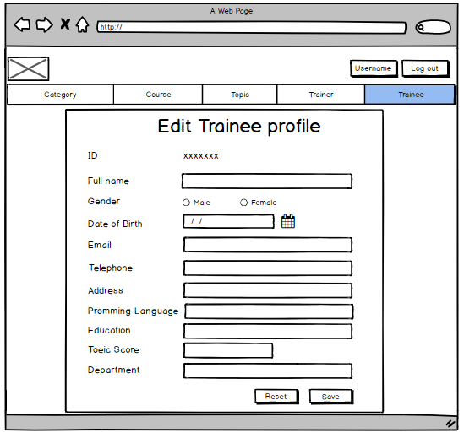
Figure 30 : Wire frame for edit trainee profile
No | Item | Description | Constraints
1 | Logo picture | The logo of the application and it is assigned the home page link.
2 | Username label | Show the username of the login account and assigned profile page link to it
3 | Log out button | User will log out the application if click on it.
4 | Id label | Display the id of trainee
5 | Full name text box | Input field for trainee name | Min 3 characters and Max 20 characters.
6 | Male and female radio button | User can select trainee gender
7 | Date of birth date input field | Input field for date of birth
8 | Email text box | Input field for email | Email syntax
9 | Telephone text box | Input field for phone number | Only number characters
10 | Address text box | Input field for address | Min 3 characters
11 | Programming language text box | Input field for programming language | Min 1 characters and Max 20 characters.
12 | Education text box | Input field for education | Min 3 characters and Max 20 characters.
13 | TOEIC Score number input field | Input field for trainee TOEIC score | - Integer value  - Min 0 and Max 1000
14 | Department text box | Input field for department | Min 3 characters and Max 20 characters.
15 | Reset button | The button will reset the value of all input field
16 | Save button | The button will update the trainee profile information.

  - Login as Trainer
- Home page
In the home page, trainers will see list of courses they have to teach. In here, they can also see the topics they are assigned to.
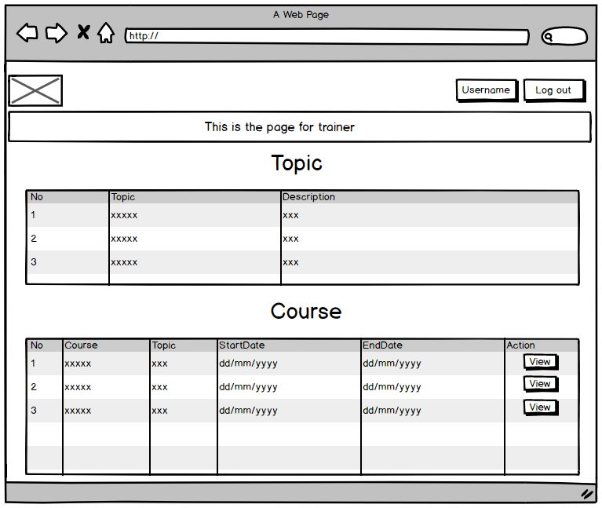
Figure 31 : Wire frame of home page for trainer

No | Item | Description | Constraints
1 | Logo picture | The logo of the application and it is assigned the home page link.
2 | Username label | Show the username of the login account and assigned profile page link to it
3 | Log out button | User will log out the application if click on it.
4 | Topic table | User can see list of topics they are assigned to
5 | Course table | User can see list of courses they are assigned to
6 | View button | User will go to page show course detail information if click on it

- Profile page
The below page show the profile information of trainer. In here, trainers can edit their profile by click the “Save” button after change the information. Furthermore, the Profile page can be visited easily by click the button “Username” in the above right corner.
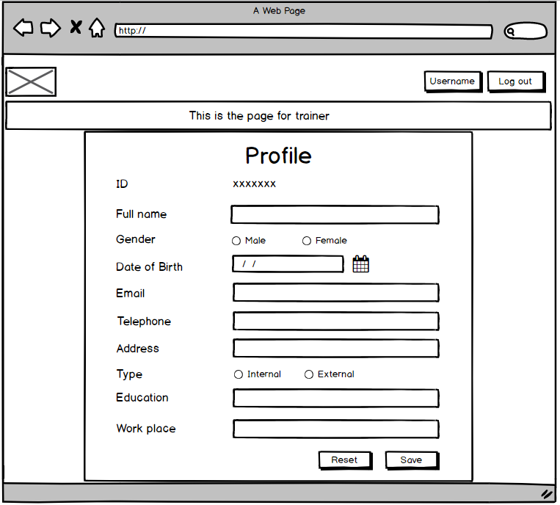
Figure 32 : Wire frame for trainer profile page
No | Item | Description | Constraints
1 | Logo picture | The logo of the application and it is assigned the home page link.
2 | Username label | Show the username of the login account and assigned profile page link to it
3 | Log out button | User will log out the application if click on it.
4 | Id label | Display the id of trainer
5 | Full name text box | Input field for trainer name | Min 3 characters and Max 20 characters.
6 | Male and female radio button | User can select trainer gender
7 | Date of birth date input field | Input field for date of birth
8 | Email text box | Input field for email | Email syntax
9 | Telephone text box | Input field for phone number | Only number characters
10 | Address text box | Input field for address | Min 3 characters
11 | Internal and external radio button | User can select trainer type
12 | Education text box | Input field for education | Min 3 characters and Max 20 characters.
13 | Work place text box | Input field for work place | Min 3 characters
14 | Reset button | The button will reset the value of all input field
15 | Save button | The button will update the trainer profile information.

- Course detail page
In the Course detail page, trainers will see the detail of the course. Also they can see the list of trainees who are assigned to the course. To see the specific course detail, trainers have to click the “View” button which in the same row with that course in the table located at home page.
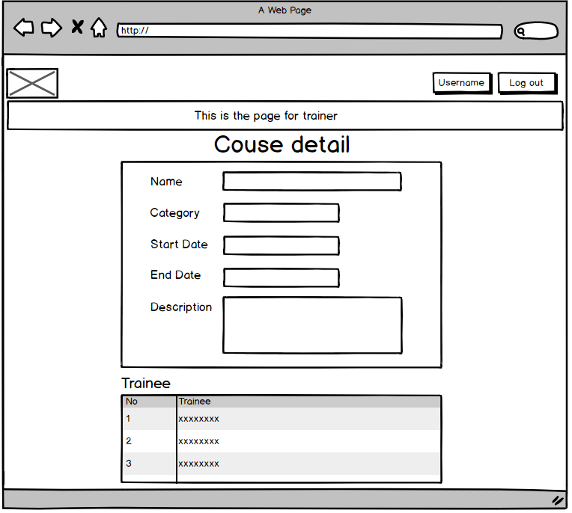
Figure 33 : Wire frame for show the detail of course

No | Item | Description | Constraints
1 | Logo picture | The logo of the application and it is assigned the home page link.
2 | Username label | Show the username of the login account and assigned profile page to it.
3 | Log out button | User will log out the application if click on it.
4 | Name text box | Display the course name | Read only
5 | Category text box | Display category of the course | Read only
6 | Start date text box | Display start date of the course | Read only
7 | End date text box | Display end date of the course | Read only
8 | Description text area | Display the description | Read only
9 | Trainee table | The table show list of trainees who is assigned to the course.

  - Login as Trainee
- Home page
In the home page, trainees will see list of courses they have to took.
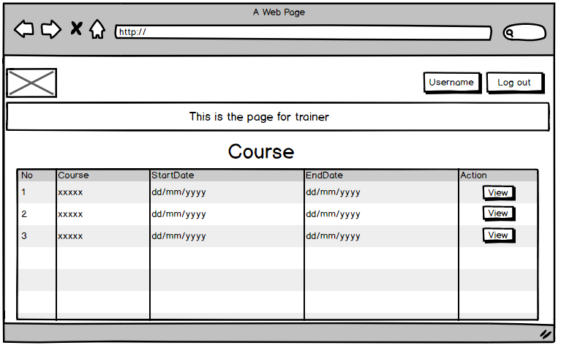
Figure 34 : Wire frame of home page for trainee
No | Item | Description | Constraints
1 | Logo picture | The logo of the application and it is assigned the home page link.
2 | Username label | Show the username of the login account and assigned profile page link to it
3 | Log out button | User will log out the application if click on it.
4 | Course table | User can see list of courses they are assigned to
5 | View button | User will go to page show course detail information if click on it

- Profile page
The below page show the profile information of trainee. In here, trainees can edit their profile by click the “Save” button after change the information. Furthermore, the Profile page can be visited easily by click the button “Username” in the above right corner.
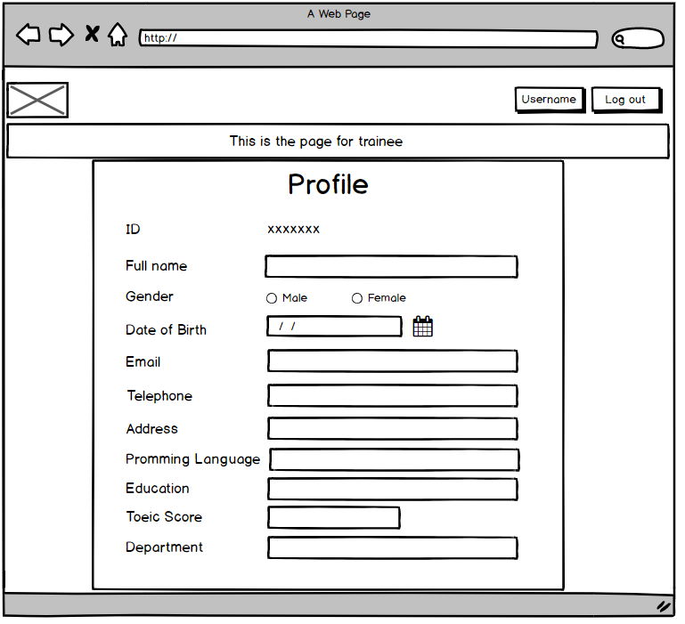
Figure 35 : Wire frame for show profile of trainee
No | Item | Description | Constraints
1 | Logo picture | The logo of the application and it is assigned the home page link.
2 | Username label | Show the username of the login account and assigned profile page link to it
3 | Log out button | User will log out the application if click on it.
4 | Id label | Display the id of trainee
5 | Full name text box | Display trainee name | Read only
6 | Male and female radio button | Display trainee gender | Read only
7 | Date of birth date input field | Display date of birth | Read only
8 | Email text box | Display email | Read only
9 | Telephone text box | Display phone number | Read only
10 | Address text box | Display address | Read only
11 | Programming language text box | Display programming language | Read only
12 | Education text box | Display education | Read only
13 | TOEIC Score number input field | Display trainee TOEIC score | Read only
14 | Department text box | Display department | Read only

- Course detail page
In the Course detail page, trainees will see the detail of the course. Also they can see the list of trainers and the topics they will teach in the course. To see the specific course detail, trainers have to click the “View” button which in the same row with that course in the table located at home page.
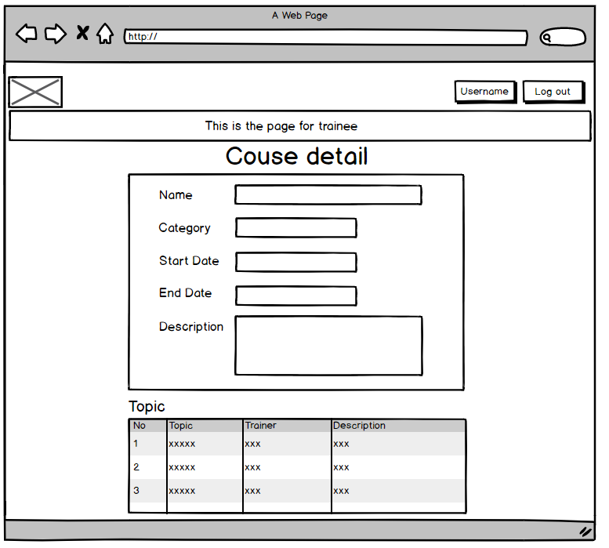
Figure 36 : Wire frame for show the course detail
No | Item | Description | Constraints
1 | Logo picture | The logo of the application and it is assigned the home page link.
2 | Username label | Show the username of the login account and assigned profile page to it.
3 | Log out button | User will log out the application if click on it.
4 | Name text box | Display the course name | Read only
5 | Category text box | Display category of the course | Read only
6 | Start date text box | Display start date of the course | Read only
7 | End date text box | Display end date of the course | Read only
8 | Description text area | Display the description | Read only
9 | Topic table | The table show list of topic, which is assigned to the course, and its trainer

- Table of questions to identity the risk
No | Questions | Answers
1 | In the requirement do not includes the role of trainees. Should we allow trainees to login the application? | Although these are no specific detail of role for trainee, the application should allow them to participate. Because it is quite inconvenience for trainees if they can not check the courses schedule. My suggestion is to provide the interface to let trainee see their courses schedule.
2 | In the use case diagram of trainee, we only let them to see the theirs profile information but do lot let them modify it. For better convenience, we should allow the permission for trainers , shouldn’t we? | The requirements of the application does not require to specific functions to trainees. Providing so many permission to trainees is not necessary. Furthermore, in my opinion, trainees should not be allowed to modified their profile in most case. Therefore, it is quite risky to programme this function to the application.
3 | In the ERD, I see that it does not include the table for admin. According to the requirement, admin take an important role in the system. It is inappropriate for not having the data for the admin, isn’t it? | The problem was considered before designing the ERD. The answer is unnecessary for including the data of administrators. Because the data seem kind of redundant, the table is eliminated from the ERD. However, these are still some percentages to cause errors for the application. Therefore, we have prepared several plans to fix the possible risks when it happens.
4 | The designed wire frame of the application seems quite simple. This may cause the customer to unsatisfied with the interface. Should we use the more attractive design? | The application is designed for education purpose. Therefore, attractive design was not considered. However, to ensure the satisfaction of customer, the design will be presented to them before programming. If they are not satisfied by the interfaces, the attractive design will be considered.

References
- En.wikipedia.org. 2020. Model–View–Controller. [online] Available at: <https://en.wikipedia.org/wiki/Model%E2%80%93view%E2%80%93controller> [Accessed 20 April 2020].
- Mona Media. 2020. MVC Là Gì? Ứng Dụng Của Mô Hình MVC | Thiết Kế Web Monamedia. [online] Available at: <https://monamedia.co/mvc-la-gi-ung-dung-cua-mo-hinh-mvc-trong-lap-trinh/> [Accessed 20 April 2020].
- BAC TRAINING & CONSULTANCY. 2020. UML USE CASE DIAGRAM – Quan Điểm Phân Tích Nghiệp Vụ. [online] Available at: <https://www.bacs.vn/vi/blog/ky-nang/uml-use-case-diagram-quan-diem-phan-tich-nghiep-vu-1872.html> [Accessed 21 April 2020].
- Fakhroutdinov, K., 2020. Use Case Diagrams Are UML Diagrams Describing Units Of Useful Functionality (Use Cases) Performed By A System In Collaboration With External Users (Actors).. [online] Uml-diagrams.org. Available at: <https://www.uml-diagrams.org/use-case-diagrams.html> [Accessed 21 April 2020].
- En.wikipedia.org. 2020. Class Diagram. [online] Available at: <https://en.wikipedia.org/wiki/Class_diagram> [Accessed 21 April 2020].
- &rarr;, V., 2020. Class Diagram Relationships In UML Explained With Examples. [online] Creately Blog. Available at: <https://creately.com/blog/diagrams/class-diagram-relationships/> [Accessed 23 April 2020].
- Visual-paradigm.com. 2020. What Is Entity Relationship Diagram (ERD)?. [online] Available at: <https://www.visual-paradigm.com/guide/data-modeling/what-is-entity-relationship-diagram/> [Accessed 23 April 2020].
- Docs.axure.com. 2020. Flow Diagrams · Axure Docs. [online] Available at: <https://docs.axure.com/axure-rp/reference/flow-diagrams/> [Accessed 21 April 2020].
- Experience UX. 2020. What Is Wireframing?. [online] Available at: <https://www.experienceux.co.uk/faqs/what-is-wireframing/> [Accessed 23 April 2020].
- Visual-paradigm.com. 2020. What Is Entity Relationship Diagram (ERD)?. [online] Available at: <https://www.visual-paradigm.com/guide/data-modeling/what-is-entity-relationship-diagram/> [Accessed 23 April 2020].

